Bandwidth and throughput

Bandwidth

Streaming movie or playing PVP requires reliable, fast connections

To support these “ high bandwidth” applications, networks have to be capable of transmitting and receiving bits at a very high rate

The rate of data transfer is usually discussed in terms of badwidth and throughput

**ITS THE capacity if a medium to carry data**

Digital bandwidth measures the amount of data that can flow from one place to another in a given amount of time bandwidth is typically measured in the number of bits that can be sent across the media in a second

Thousands of bits per second (Kbps)  
 Millions of bits per seconds (Mbps)  
 billions of bits per second (Gbps)

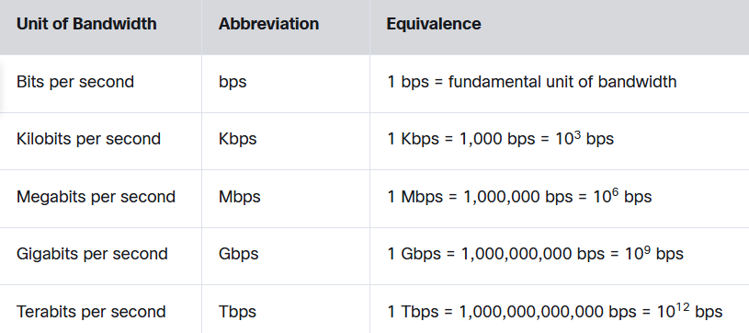

Throughput

**It’s the measure of the transfer of bits across the media over a given period of time**

However, due to a nember of factors, it does not usually match the specified bandwidth

They can be influenced by:  
 - amount of data being sent and received over the connection  
 - the type of data being transmitted

- the latency created by the number of network devices encountered between sources and destination

· **Bandwidth** = Maximum capacity.

· **Throughput** = Actual data transfer speed.